Speaker profile: Dr Thomas Semple
SEO:

Search term | Dr Thomas Semple
H1 | Dr Thomas Semple
URL: | /our-specialists/Thomas-semple
Meta title tag (<60 characters, excluding the brand name): | Dr Thomas Semple | Royal Brompton & Harefield Hospitals Education
Meta description (70-155 characters): | Dr Thomas Semple is a paediatric and cardiothoracic radiologist and clinical lead for congenital cardiac computed tomography (CT).

Content:

Our specialists landing page:

Header block:

Image | RESOURCE ID  Alt text:
Name | Dr Thomas Semple
Title | Paediatric and cardiothoracic radiologist
Short summary (under 10-15 words)  You need to re-word the main website version to avoid duplicate copy. | Specialises in the heart and lung conditions in neonates, infants, children and adults
Specialist area – select all that apply | Cardiac surgery | ☐
Specialist area – select all that apply | Cardiology | ☐
Specialist area – select all that apply | General medicine | ☐
Specialist area – select all that apply | Paediatrics | ☐
Specialist area – select all that apply | Radiology | ☒
Specialist area – select all that apply | Respiratory medicine | ☐
Specialist area – select all that apply | Thoracic surgery | ☐
Specialist area – select all that apply | Vascular surgery | ☐

Content block 2:

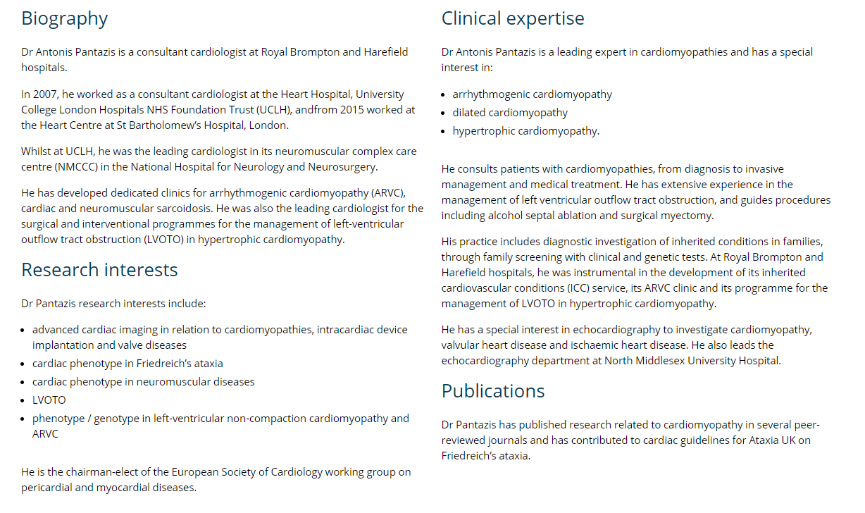

Please note: Text for each section needs to be roughly the same length, so that the web page looks balanced. All text must be re-worded from the master website version so as not to duplicate content across websites.

Column 1:  Biography  Brief 50-100-word summary. | Dr Thomas Semple is a cardiothoracic specialist with expertise in the imaging of heart and lung conditions in neonates, infants, children, and adults.  In 2009, Dr Semple graduated from Kings College, London, and in 2016 completed his postgraduate radiology training at the University College London Hospitals’ (UCLH) training scheme. After completing his cardiac CT and paediatric radiology fellowship at Royal Brompton, Great Ormand Hospital and University College Hospital, Dr Semple undertook a two-year structural and functional lung magnetic resonance imaging (MR) fellowship at Royal Brompton, where he currently works.  Dr Semple is the clinical lead for congenital cardiac CT at Royal Brompton, and provides radiology input for multi-disciplinary team meetings, including:  - paediatric and adult congenital joint cardiology cardiothoracic (JCC)  - paediatric respiratory  - national pulmonary hypertension service (NPHS)  - paediatric intensive care imaging.
Column 2:  Clinical expertise  Brief 50-100-word summary. | Dr Thomas Semple has a variety of expertise in heart and lung procedures and services including:  - childhood interstitial lung disease (ChILD) imaging  - magnetic resonance imaging (MRI) of lung disease  - CT imaging for congenital heart disease assessment (adult and paediatric)  - Lymphatic imaging, including fluoroscopic, CT and MRI lymphangiography  - Cardiac CT imaging, including coronary, valve assessment, procedural planning including valve intervention (melody, TAVI, TMVI), left atrial appendage device planning and electrophysiology procedural planning  - Paediatric cardiac intensive care ultrasound - specifically cranial doppler and central and peripheral vascular ultrasound  - General paediatric imaging, thoracic imaging and thoracic intervention (adult and paediatric biopsies and drain insertions).
Column 3:  Research interests  Brief 50-100-word summary, if present. | Dr Thomas Semple’s research interest include:  - paediatric lung imaging (including structural and functional lung MRI)  - use of cardiac CT techniques in paediatric practice including neonatal coronary CT.
Column 4:  Publications  Brief 50-100 word summary, if present. | Dr Thomas Semple has published in topics covering paediatric and adult, cardiac and respiratory imaging He has contributed to recent editions of text books including Kendig’s disorders of the respiratory tract in children and Grainger and Allison’s Diagnostic Radiology.
Column 5:  Teaching  Brief 50-100 word summary, if present. | Dr Semple regularly speaks at imaging courses and international and national meetings. He also regularly supervises rotating registrars and Imperial College BSc students both in their day-to-day work and at scientific meetings.

Related courses and webinars to auto-populate below this.

